January 2021 Big Book Weekend Schedule
Big Book Weekend Zoom ID: 284 187 0571

Friday January 1ST: 6PM - 8:30PM PST
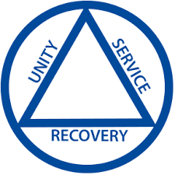
Chairperson Opening Prayer and Announcements

Speaker/Facilitators David N. & Greg S. Share Their Personal Stories & Step One Experience

Saturday January 2ND: 9AM - 5PM PST Steps 2-7

9am - 9:50am: Step 2 with Q & A

10am – 10:50am: Step 3 with Q & A

11am – 11:50am Step 4 with Q & A

Lunch: 12pm – 1pm

1pm – 1:50pm Step 5 with Q & A

2pm – 2:50pm Steps 6 & 7 with Q & A

3pm – 3:50pm Steps 8 & 9 with Q & A

4pm – 4:50pm Reviewing Steps 2-9 Sharing Personal Experiences

Sunday January 3RD: 10am - 3pm PST

10am – 10:50am: Step 10 with Q & A

11:00am – 11:50am: Step 11 with Q & A

Lunch 12pm - 1pm

1pm - 2pm: Step 12 with Q & A

2pm – 2:15pm: Chairperson Announcements & Closing Prayer

